Trifour Data
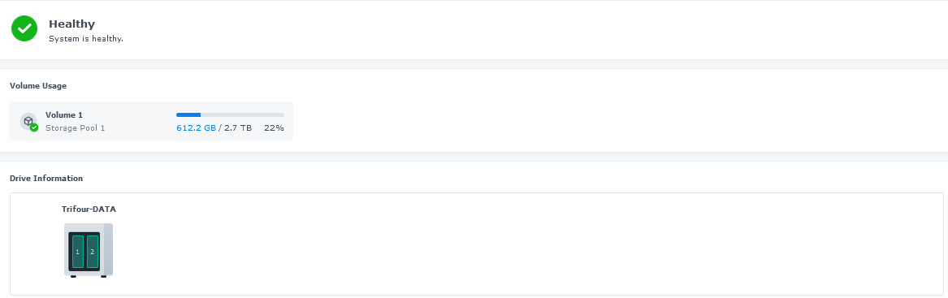
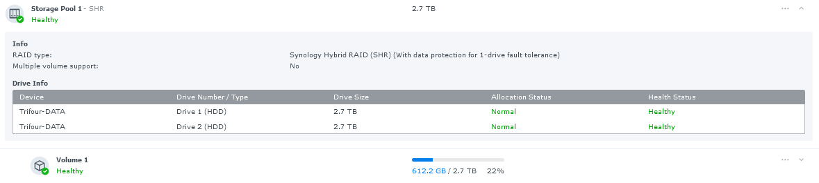

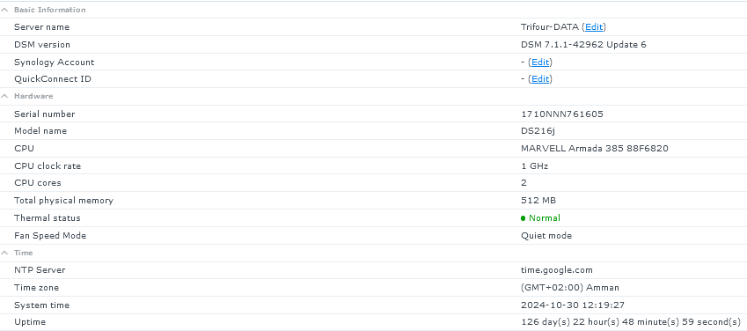
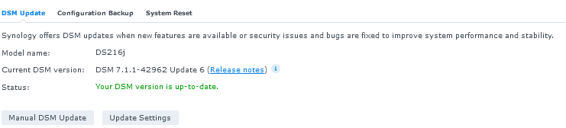

Config Backup: Done

